**Project Planning Phase**

Project Planning Template (Product Backlog, Sprint Planning, Stories, Story Point)

|  |  |
| --- | --- |
| Date | 09 November 2022 |
| Team ID | PNT2022TMID30683 |
| Project Name | Estimate the Crop Yield using Data Analytics |
| Maximum Marks | 8 Marks |

Product Backlog, Sprint Schedule, and Estimation (4 Marks)

|  |  |  |  |  |  |  |
| --- | --- | --- | --- | --- | --- | --- |
| Sprint | Functional Requirement  (Epic) | User Story Number | User Story & task | Story Points | Priority | Team Members |
| Sprint-1 | Registration | USN-1 | I can sign up for the application as a user by providing my email address, a password, and a password confirmation. | 2 | High | Vinotha  Yogakiruthiga  Poongodi  Sumithra |
| Sprint-1 |  | USN-2 | After registering for the application, I as a user will receive a confirmation email. | 1 | High | Vinotha  Sumithra |
| Sprint-2 |  | USN-3 | I can sign up for the application as a user using Google. | 2 | Low | Vinotha  Poongodi |
| Sprint-1 |  | USN-4 | I can sign up for the application as a user using Gmail. | 2 | Low | Vinotha  Yogakiruthiga |
| Sprint-1 | Login | USN-5 | I can access the application as a user by providing my email address and password. | 1 | High | Poongodi  Yogakiruthiga |
| Sprint-3 | Dashboard | USN-6 | I am free to use my dashboard and explore the features as a user. | 2 | High | Sumithra  Poongodi  Yogakiruthiga  Vinotha |
| Sprint-2 |  | USN-7 | I can access using the credentials as a user the assets I’m applying for. | 2 | High | Yogakiruthiga  Sumithra |
| Sprint-3 |  | USN-8 | Data manipulation operations carried out by the application. | 1 | High | Vinotha  Poongodi |
| Sprint-3 | Visualization | USN-9 | Can use certain datasets to generate dashboards. | 2 | Medium | Vinotha  Sumithra |
| Sprint-4 |  | USN-10 | One can perform predictive analysis. | 1 | High | Sumithra  Poongodi |
| Sprint | Functional Requirement  (Epic) | User Story Number | User Story & task | Story Points | Priority | Team Members |
| Sprint-3 |  | USN-11 | With certain datasets, I can produce stories. | 2 | High | Vinotha  Yogakiruthiga |
| Sprint-4 |  | USN-12 | Can export and send reports in accordance with the built-in dashboards and stories. | 2 | High | Yogakiruthiga  Poongodi  Vinotha |

Project Tracker, Velocity & Burndown Chart: (4 Marks)

|  |  |  |  |  |  |  |
| --- | --- | --- | --- | --- | --- | --- |
| Sprint | Total Story Point | Duration | Sprint Start Date | Sprint End Date(Planned) | Story Points Completed (as on planned end date) | Sprint Release date(actual) |
| Sprint-1 | 20 | 6 days | 24 Oct 2022 | 29 Oct 2022 | 20 | 29 Oct 2022 |
| Sprint-2 | 20 | 6 days | 31 Oct 2022 | 05 Nov 2022 | 20 | 05 Nov 2022 |
| Sprint-3 | 20 | 6 days | 07 Oct 2022 | 12 Nov 2022 | 20 | 12 Nov 2022 |
| Sprint-4 | 20 | 6 days | 14 Oct 2022 | 19 Nov 2022 | 20 | 19 Nov 2022 |

**Velocity:**

Consider a scenario in which the sprint will last 10 days and the team's velocity is 20. (Points per sprint). Let's determine the group's average velocity (AV) for each iteration (story points per day).

**AV = Sprint Duration/Velocity**

**AV = 20/10 = 2**

AV = Sprint Duration/Velocity = 20/6 = 3

**Burndown Chart:**

A burn down chart plots the amount of work remaining to perform against the amount of time. In agile software development approaches like Scrum, it is frequently employed. Burn down charts, however, can be used for any project that makes observable progress over time.

**PNT2022TMID30683**

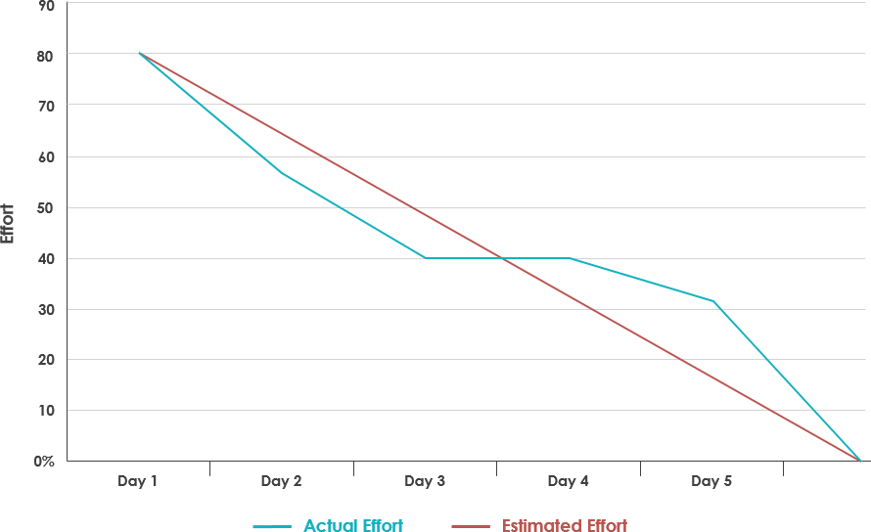

[**https://www.visual-paradigm.com/scrum/scrum-burndown-chart/**](https://www.visual-paradigm.com/scrum/scrum-burndown-chart/)

[**https://www.visual-paradigm.com/scrum/scrum-burndown-chart/**](https://www.visual-paradigm.com/scrum/scrum-burndown-chart/)

**Reference :**

[**https://www.atlassian.com/agile/project-management**](https://www.atlassian.com/agile/project-management)

[**https://www.atlassian.com/agile/tutorials/burndown-charts**](https://www.atlassian.com/agile/tutorials/burndown-charts)

[**https://www.atlassian.com/agile/tutorials/epics**](https://www.atlassian.com/agile/tutorials/epics)

<https://asana.com/resources/burndown-chart>